**Tutorial 38: Vue Router - Route Parameters**

In this tutorial we will focus how we will set up route parameters in our application. Route parameters are used to navigate to a specific page that contains information that is unique from the others. An example is we have a list of jobs but we want to navigate to a page that will allow us to see me information about that job, using router parameters will allow us to do so. Route parameters using come towards the end of the URL that specifies the path to the id or name of the page related to information we will see.

Below is an example of the URLs with a route parameter:

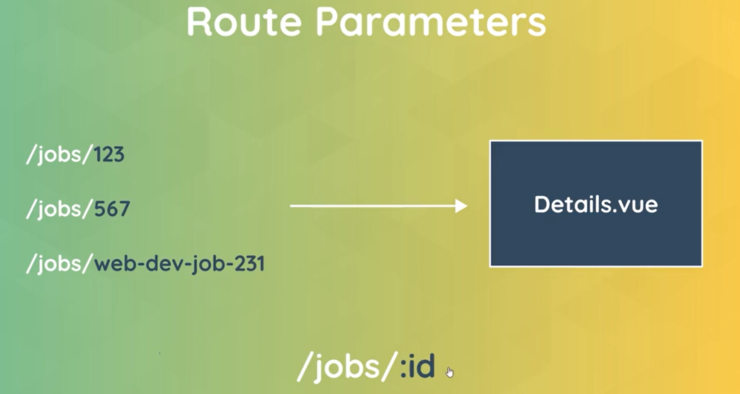

Make sure **Tutorial 37** is complete to be able to move on to this tutorial or clone the [vue3-firebase-course](https://github.com/younggrasshopperza/vue3-firebase-course) repository and go to branch called **Tutorial-37** and navigate to the young-grasshopper-jobs folder.

**Step 1:** Inside the router file, in the index.js page, we are going to create a new route for the jobDetails. Inside the routes array at the bottom, create another object for the route. At the end of the path include the route parameter /:id . This allows us to pass some sort of value in the URL.Import the JobDetails component to register the component in the route.

Look at the example below (**Line 5 and between line 23 and 27**):

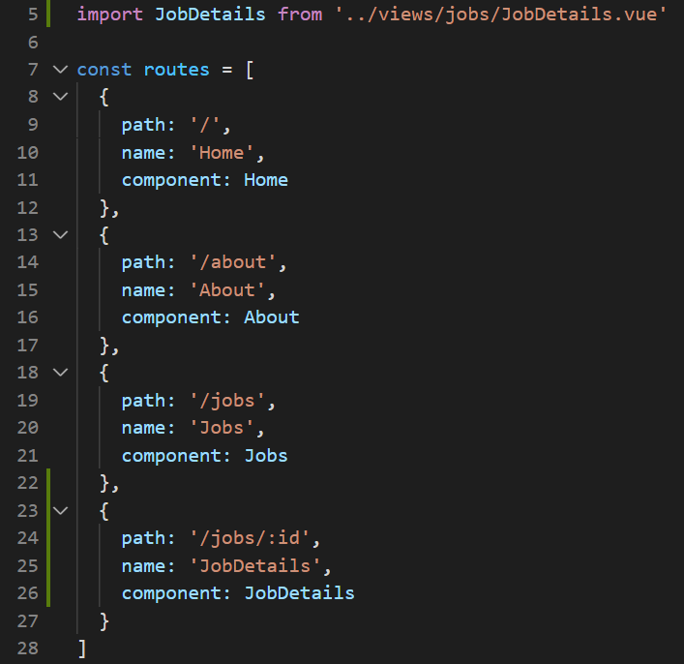

**Step 2:** Inside the JobDetails.vue file, create an h1 tag inside the template.

We are going to test and see whether we can reach the page. Go to the browser of the website and inside the URL of your localhost navigate to the Jobs page. Go to the URL and /1 in front of localhost:8080/jobs

Example:

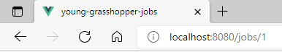

**Output:**

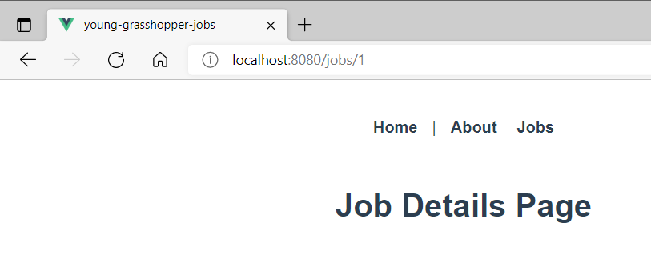

Vue recognises that we are following the same structure as the file path we created inside the object in the index.js file. The :id is interchangeable depending.

**Step 3:** Inside the JobDetails.vue file, create a p tag under the h1 tag. Inside the p tag type the following “The job id is {{ **$route.params.id** }}”

Look at the example below (**Line 3**):

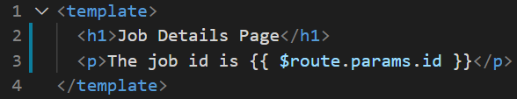

**Output:**

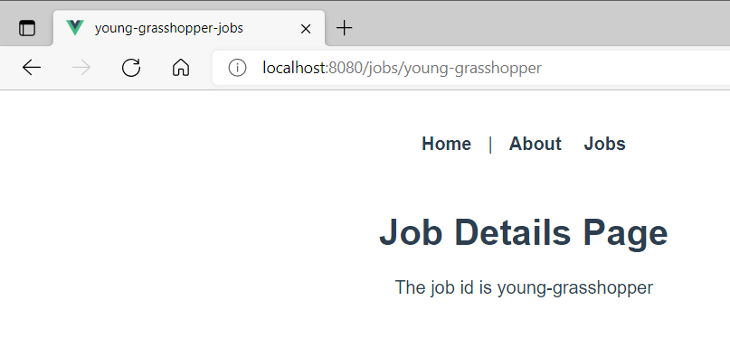

**$route** is the route object. It contains information about the current route, including an route parameters.

**$route.params** allows us to access the route parameter.

**$route.params.id** is the specific route parameter we created. We called the route parameter :id therefore we need to put id at the end.

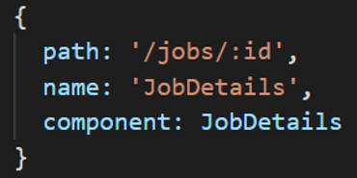

If we called the route parameter slug then the route parameter would like this **$route.params.slug**

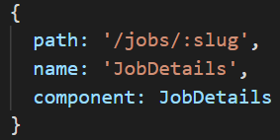

**Step 4:** Inside the JobDetails.vue file, create a data property called id that stores the data of the current route parameter. The value of the id is **this.$route.params.id**. Inside the p tag, replace **$route.params.id** with **id**.

Look at the example below (**Line 3 and between line 8 and 12**):

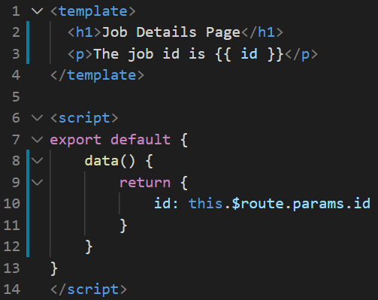

**Output:**

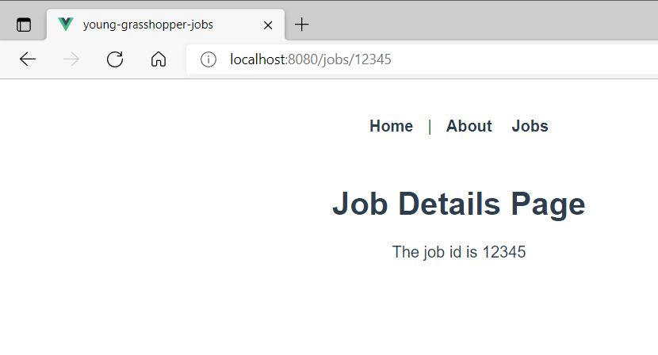

**You can view the code snippets from the** [**vue3-firebase-course**](https://github.com/younggrasshopperza/vue3-firebase-course) **repository under the Tutorial-38 branch**.